**Short note on RTC :**

Resources : [(1)](http://www.exploreembedded.com/wiki/RTC) [(Datasheet)](https://www.sparkfun.com/datasheets/Components/DS1307.pdf)  
  
1. The contents of the time and calendar registers are in the BCD format.

2. Bit 7 of register 0 is the clock halt (CH) bit. When this bit is set to a 1, the oscillator is disabled. When cleared to a 0, the oscillator is enabled  
**Please note that the initial power-on state of all registers is not defined. Therefore, it is important to enable the oscillator (CH bit = 0) during initial configuration.**

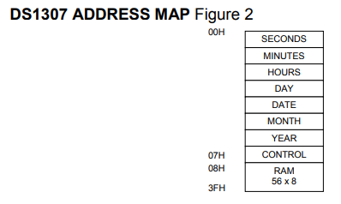

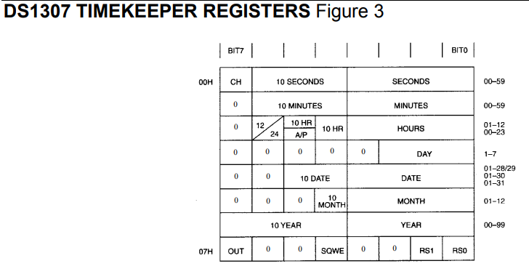

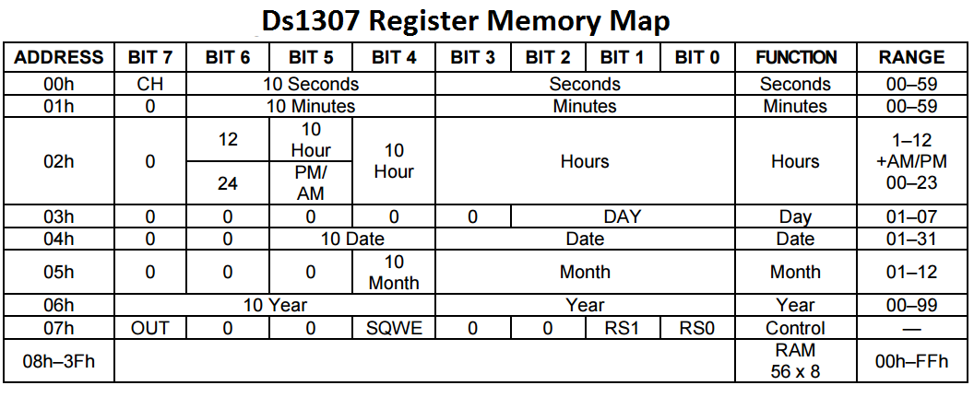

3. **Bit 6** of the **hours register** is defined as the **12- or 24-hour mode select bit**.

a) high : the 12-hour mode is selected.   
 i) In the 12-hour mode, bit 5 is the AM/PM bit with logic high being PM.   
 b) In the 24-hour mode, **bit 5 is the second 10 hour bit (20- 23 hours).**

**Extra Info : 2-Wire Start**

**The control register is the key to RTC. Understanding it is very important. We should also understand how we control the SQW ( Square Wave ) / Out pin and the consequent wave form (Output) from the RTC.**

**We have a control register of it 07h. ( Not sure if it is 07h ) à Doubt Solved**

**Each bit in the Control Register is divided as shown below**



Bit 7 (out) and Bit 4(SQWE) are connected

Firstly function of these 2 :

If SQWE = 1 , AND , OUT = 1 , SQW/OUT PIN = 1

SQWE = 1 , AND , OUT = 0 , SQW/OUT PIN = 0

**Question : What happens when SQWE = 0 ?**

**Question : We have 4 Frequencies in which the RTC can give an output. We cannot connect it directly with the MCU. There would be data loss unless we connect it with an I2C.  
However in the circuit I did not see a I2C.**

The RS (Rate Select) Bit : This is a collection of 2 bits RS0 and RS1. The frequency of the square wave output of the RTC depends on these two bits.

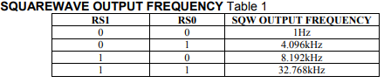

**Procedure of an RTC**

1. Access is obtained by implementing a START condition
2. provide a device identification code followed by a register address
3. registers can be accessed sequentially until a STOP condition is executed
   1. VCC falls below 1.25 x VBAT :  
      i) device terminates an access in progress and resets the device address counter  
      ii) Read and write inhibited  
      Reason : prevent erroneous data from being written to the device from an out of tolerance system.
   2. When VCC falls below VBAT the device switches into a low-current battery backup mode.
   3. The RAM and timekeeper are switched over to the external power supply

**This maybe 07h on the Register Memory Map( Doubt Solved )** 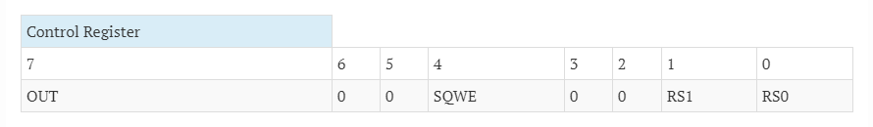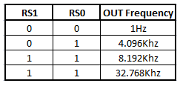

1. Now we need to sequentially write data (Ex: Seconds, minutes, date, etc)
2. Once this data is written the RTC will automatically keep counting and incrementing it.
3. **Disable the OUT/SQW pin of RTC ??**
4. STOP Transmission by using the STOP command which is issued by Master ( ATMega32 )

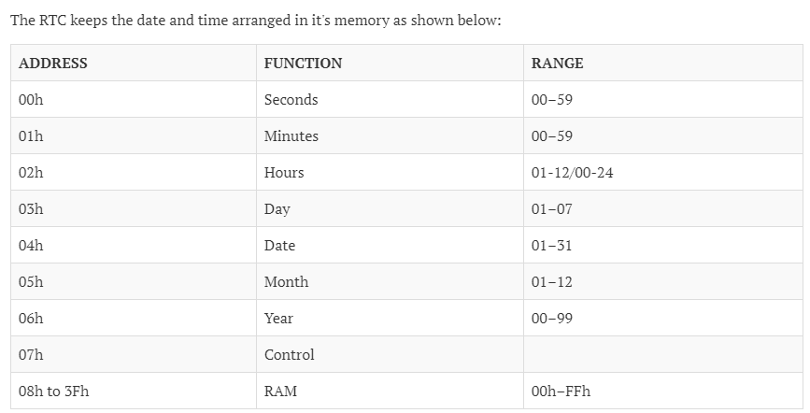

**Interfacing RTC DS1307 with ATMega32.**

1. First Master ( ATMega32 ) sends the device ID to RTC.
2. **SCL:** This pin must be connected to SCL pin of the I2C Bus/Master.
3. **SDA:** This pin must be connected to SDA pin of the I2C Bus/Master.
4. **Code ( Library) :** First a library must be defined which has the following functions in order :
   1. Defining all variables that you want to access/use.
   2. Defining the variables as constant :
      1. Read Slave address for DS1307 – [ D1(hex) OR 11010001 (binary) ]
      2. Write Slave Address for DS1307 – [ D0(hex) OR 11010001 (binary) ]
      3. Seconds Address in DS1307 ( 0x00 ). **Are all others counted ??**
      4. Date Address in DS1307 ( 0x04 ). **Are all others counted ??**
      5. Control Register Address in DS1307 ( 0x07 ).
   3. Define all the functions that we are going to use
      1. Read
      2. Write
      3. **….. Not sure if more are there …..**
5. **Code:** 
   1. Start communication
   2. Write the initial Values in the registers
   3. Read those values
   4. Stop Communication after data is read

CODE DISCUSSION and IDEA - BOARD

Expected Errors:

1. BCD to Binary and Binary to BCD Conversion
2. Where is the I2C Library??
3. What all do we want to display on the LCD
4. Displaying something on the LED is okay, but how will be take data from RTC and give it to LCD?  
     
   Ans: RW Pin should be high ??
5. How will we set Clock Frequency ??

What is Left:

1. Writing code for Binary to BCD and BCD to Binary (Chinmay)